

DRAFT
Technical Specification

Melbourne IT OFC
MEL IT AP Payables Invoices Report

Author: Tony Whelan
Creation Date: 4 July 2016
Last Updated: 4 July 2016
Version: 1.0
Table of Contents

1. Requirement 3
2. Solution Overview 3
3. Technical Objects 4
3.1 BI Publisher XML Data Definition File 4
3.2 BI Publisher RTF Report Template 4
4. Configuration 4
4.1 Define Concurrent Program 4
4.2 Define XML Data Definition 6
4.3 Define XML Template 6
4.4 Update Request Group 7
5. Report Execution 7

Requirement

Melbourne IT have a requirement for a Payables Invoices Report listing details of all AP Payables Invoices for a range of user parameters.

The Data columns include:
Business Unit
Supplier Number
Supplier Name
Supplier Site
Invoice Number
Invoice Date
GL Date
Created By
Creation Date
Amount
Invoice Currency
Description
Amount Paid
Payment Currency
Check Number
Payment Date

The Parameters include:
Invoice Date Range
Payment Date Range
Invoice Currency
Vendor Name
Business Unit.

Solution Overview

Report MEL IT AP Payables Invoice Report has been developed and configured using the Oracle EBS XML BI Publisher. This document describes the configuration and execution of XML Report MEL IT AP Payables Invoices Report to provide the above information.

Technical Objects

BI Publisher XML Data Definition File
This file contains the SQL query, data elements and parameters for the report.
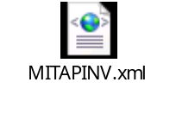

BI Publisher RTF Report Template
This file contains the xml markup and report layout definition for the report.
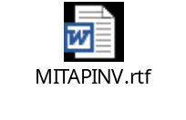

Configuration

Define Concurrent Program
Responsibility: System Administrator
Menu Path: Concurrent -> Program -> Define
Form: Concurrent Program
Purpose: Define a new concurrent program.

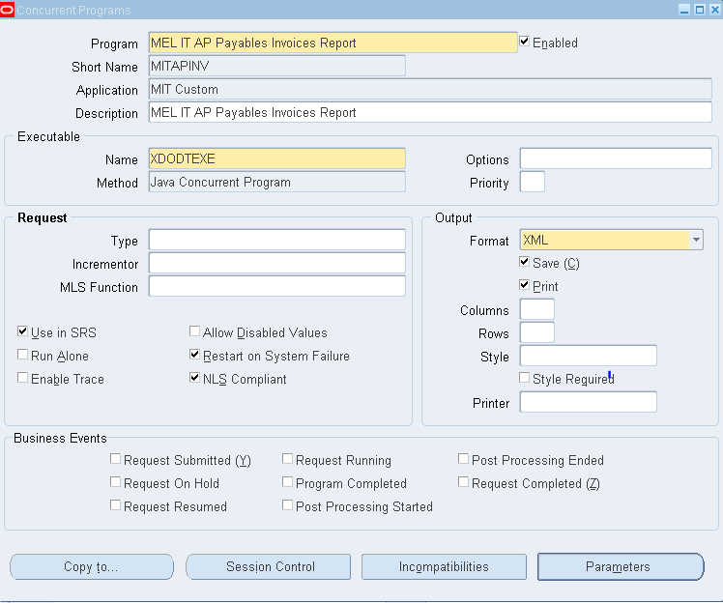

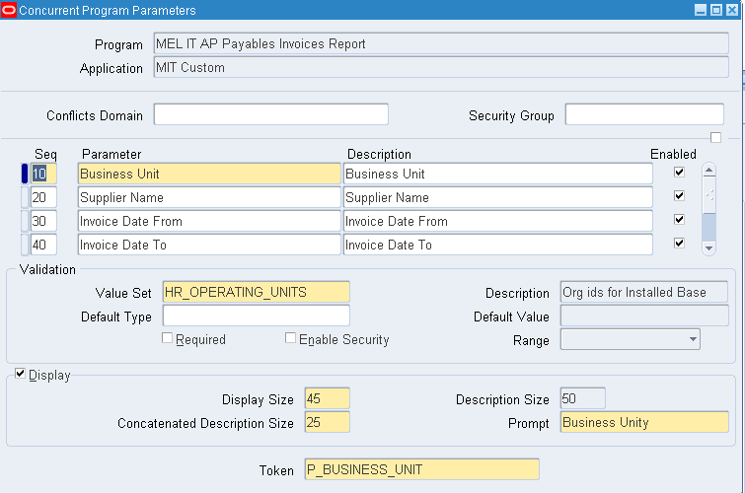

Parameters:
Seq. | Parameter | Value Set | Disp. Size | Prompt | Change Reference
10 | Business Unit | HR_OPERATING_UNITS | 45 | Business Unit | P_BUSINESS_UNIT
20 | Supplier Name | AP_SRS_SUPPLIER_NAME | 45 | Supplier Name | P_SUPPLIER_NAME
30 | Invoice Date From | AP_SRS_INVOICE_START_DATE | 11 | Invoice Date From | P_INVOICE_DATE_FROM
40 | Invoice Date To | AP_SRS_INVOICE_END_DATE | 11 | Invoice Date To | P_INVOICE_DATE_TO
50 | Payment Date From | AP_SRS_INVOICE_START_DATE | 11 | Payment Date From | P_PAYMENT_DATE_FROM
60 | Payment Date To | AP_SRS_INVOICE_END_DATE | 11 | Payment Date To | P_PAYMENT_DATE_TO
70 | Invoice Currency | AP_SRS_CURRENCY | 15 | Invoice Currency | P_INVOICE_CURRENCY

Define XML Data Definition
Responsibility: XML Publisher
Menu Path: Home -> Data Definitions
Form: Data Definition
Purpose: Define the Data Definition in XML Publisher; attach the XML Data Definition file.

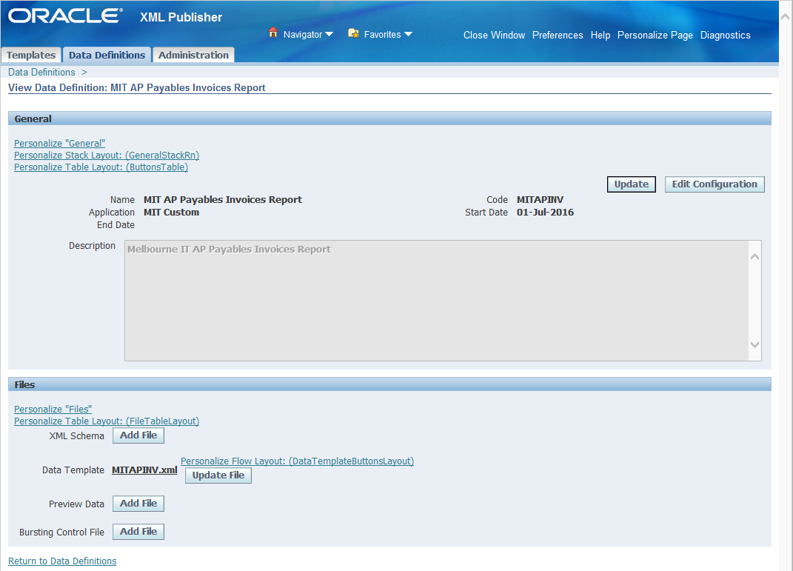

Define XML Template
Responsibility: XML Publisher
Menu Path: Home -> Templates
Form: Templates
Purpose: Define the Layout Template; attach the RTF Report Template file.

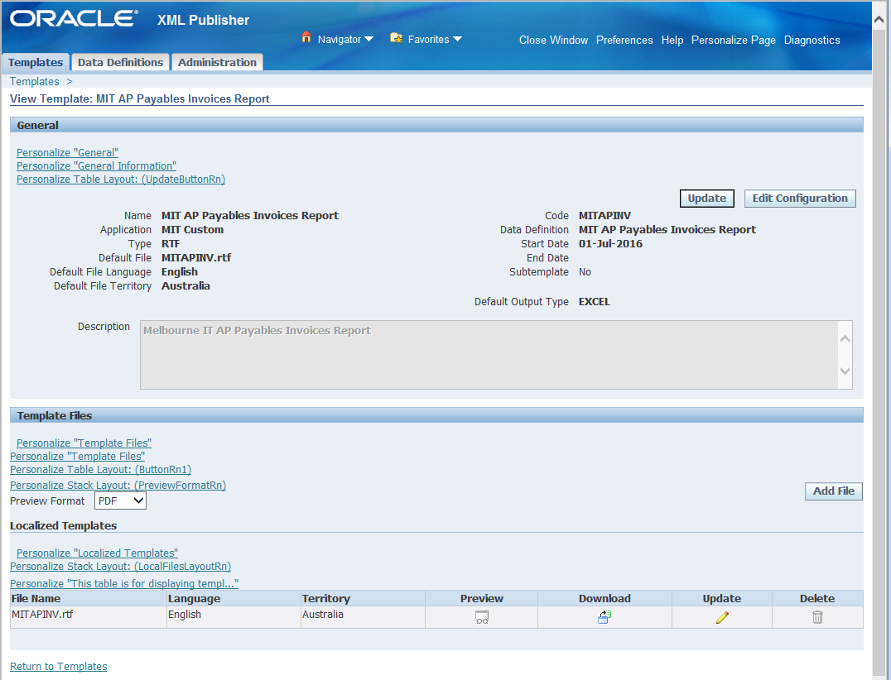

Update Request Group
Responsibility: System Administration
Menu Path: Security-> Responsibility -> Define
Form: Request Group
Purpose: Add the Report to the Payables Request Group
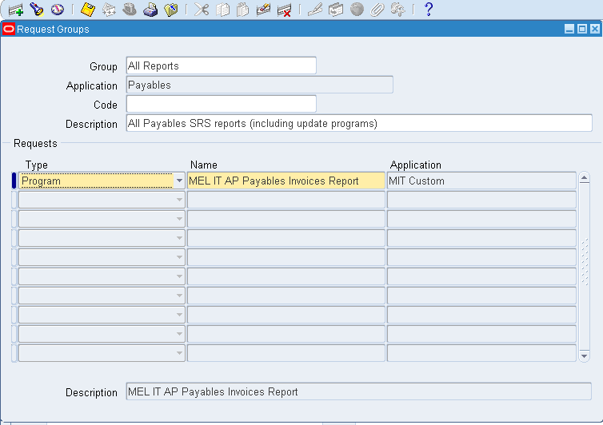

Report Execution

- Login to your Payables Responsibility and execute the Concurrent Requests program.
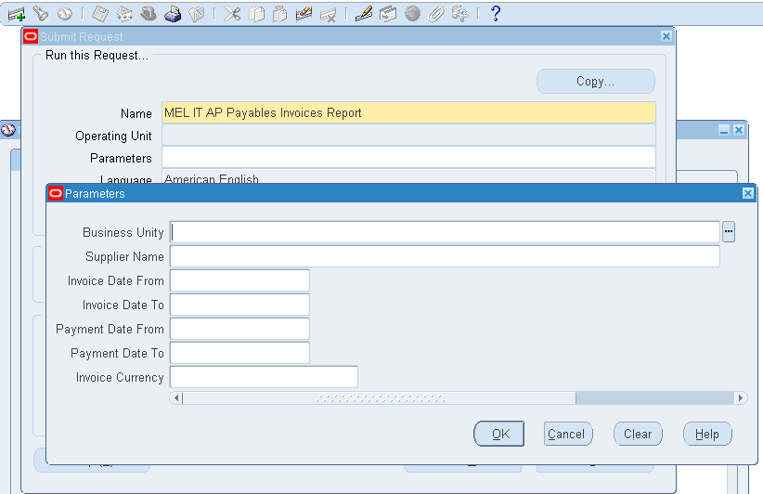

- Enter or select MEL IT AP Payables Invoices as the Name.
- Enter or select the required Parameters to limit the report data:-
  - Business Unit
  - Supplier Name
  - Invoice Date From
  - Invoice Date To
  - Payment Date From
  - Payment Date To
  - Invoice Currency
- Submit the Report.
- Execute the View -> Requests menu.
- Click the View Output button in OFC Requests form
- Click the Open or Save option in the Internet Explorer window. This will save the report in your standard Downloads folder.

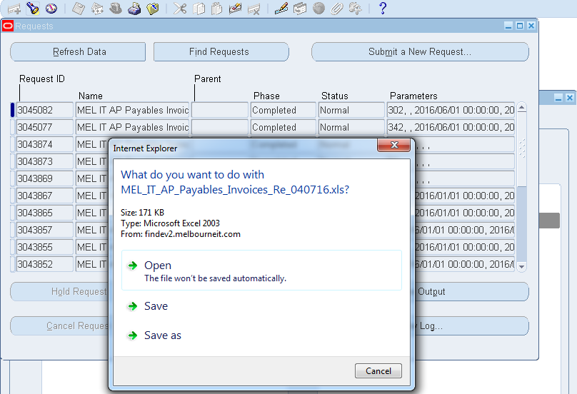

- Navigate to your Downloads folder and open the report file.

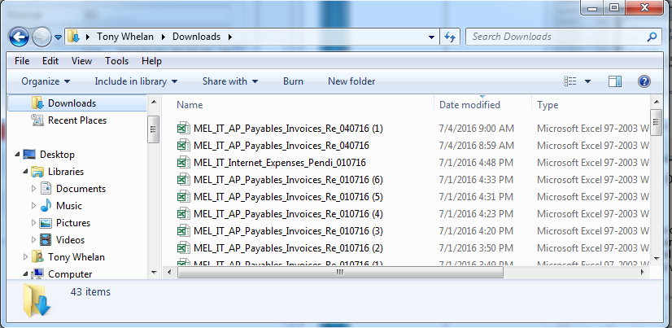

- Click ‘Yes’ to ignore the file format extension warning due to different versions of Excel between OFC and MIT.
- The report output will be displayed in Excel format.

